HOW TO START A SMALL GROUP MINISTRY
by Steve Gladen

Change is hard. To master change your paradigm must switch from what you will lose to what you will gain!

Jesus was a master at changing paradigms
- Church Matthew 21:12
- People Matthew 8
- Heart Matthew 5:28

Whether you are starting a small group ministry, or are you thinking of retooling an existing small group ministry? Here are some points you might want to consider before starting this journey.

- Know where you are ________HEADED__________.

In Individuals and Your Groups (Great Commission and great commandment)

Acts 2:42-47 NLT
“All the believers devoted themselves to the apostles’ teaching (DISCIPLESHIP), and to fellowship, and to sharing in meals (including the Lord’s Supper) (FELLOWSHIP), and to prayer. (WORSHIP)

A deep sense of awe came over them all, and the apostles performed many miraculous signs and wonders. (WORSHIP) And all the believers met together in one place and shared everything they had. They sold their property and possessions and shared the money with those in need (MINISTRY). They worshiped together at the Temple each day, met in homes for the Lord’s Supper, and shared their meals with great joy and generosity — all the while praising God and enjoying the goodwill of all the people (FELLOWSHIP). And each day the Lord added to their fellowship those who were being saved.” (EVANGELISM)

- Address…Unit of 1…begin with the end in mind

- Define success

- HA/HP

In Your Church

Acts 5:42 NIV
“Day after day, in the temple courts and from house to house, they never stopped teaching and proclaiming the good news that Jesus is the Christ.”

- Explain birth of church and messiness…control verse growth

- “Of” verse “With” verse “Is”

- What foundation…168 hours a week

- Find the ________ LAY OF THE LAND __________ in your church.

- Honor the past, they got you there (You have a job because of them)

1 Peter 3:8 NLT
“Finally, all of you should be of one mind. Sympathize with each other. Love each other as brothers and sisters. Be tenderhearted, and keep a humble attitude.”

1 Peter 2:13-14 NLT
“For the Lord’s sake, respect all human authority—whether the king as head of state, or the officials he has appointed.”

- Die on health, not language

- Interview key opinion leaders (Lead Pastors spouse)

- Survey SG and SS leaders. What’s worked? What hasn’t? What would you change?

- Do the 3C’s…Calls, coffee and calories!

Get wisdom; develop good judgment. Don’t forget my words or turn away from them.
Proverbs 4:5 (NLT)
- Row boat verse oil tanker It takes time…20 years at Saddleback

- Who will ________ RUN POINT __________?

- Availability and Capability
Paid or not paid isn’t the question—passion is the question.

- Questions to think through

Who has the passion for the people to be the healthiest followers of Christ in your church?
Who has the passion to build a delivery system to handle the people God will send your way?
Who has what Psalms 78:72 describes in David?

Psalms 78:72 NLT
“He cared for them with a true heart and led them with skillful hands.”

2 Corinthians 5:7 KJV
“For we walk by faith, not by sight.”

Who has the humility of knowing it’s not “them” but “God” (1 Corinthians 2:4-5)?

1 Corinthians 2:4-5 NLT
“And my message and my preaching were very plain. Rather than using clever and persuasive speeches, I relied only on the power of the Holy Spirit. I did this so you would trust not in human wisdom but in the power of God.”

Who is willing to do “whatever” with the right attitude?
Who is “called” and willing to learn?

- This person will be “in” because of your vision NOT need!
- Personal ask

- Who’s on the_________ TEAM _________?

- C Team
- Based on the gifting you don’t have, but similar passion
- Pray

Luke 10:2 NLT
“These were his instructions to them: ‘The harvest is great, but the workers are few. So pray to the Lord who is in charge of the harvest; ask him to send more workers into his fields.’”

- Love the sheep—smell like them
- Relationship, relationship, relationship! And relationship!
- Heart, John 10
- Compassion John 11:35…Luke 19:41
- Motivation 2 Corinthians 5:10

1 Corinthians 13:1-3 NLT
“If I could speak all the languages of earth and of angels, but didn’t love others, I would only be a noisy gong or a clanging cymbal. If I had the gift of prophecy, and if I understood all of God’s secret plans and possessed all knowledge, and if I had such faith that I could move mountains, but didn’t love others, I would be nothing. If I gave everything I have to the poor and even sacrificed my body, I could boast about it; but if I didn’t love others, I would have gained nothing.”

Proverbs 24:6 NLT
“So don’t go to war without wise guidance; victory depends on having many advisers.”

- What will be your _______ STRATEGY ___________?

Senior Pastor Buy In (Campaign Strategy)

At Saddleback Church the greatest way to start a small group ministry is through a Campaign Strategy. Now, understand if you don’t do the process outlined above, you will start a bunch of groups, but they will be purposeless and drift. To learn more about our Campaign Strategy go to Small Groups With Purpose, chapter 17.

Since I have been at Saddleback, this has been our most effective tool for aligning the church and starting small groups. Along with strategy, you need to continually cast vision. Campaign’s are successful because throughout the year our people hear from the pulpit the importance of small groups through testimonies, sermons, commercials, and most importantly through personal stories of the teaching pastors in their sermons.

- Rick, first week back after Matthew’s death
- Rick, I need a small group, are you telling me you are more spiritual than me?

Romans 12:8 NLT
“If your gift is to encourage others, be encouraging. If it is giving, give generously. If God has given you leadership ability, take the responsibility seriously. And if you have a gift for showing kindness to others, do it gladly.”

Proverbs 11:14 NLT
“Without wise leadership, a nation falls; ….”

- Organic…2 friends—find leadership
- Lower bar H-O-S-T (have pathway and infrastructure)
- DVD Curriculum empowers hospitality gifting
- Church wide Alignment
- 5 learning styles
- Technology

No Senior Pastor Buy In (Connection Strategy)

- SGWP, Chapter 16; Our Connection Strategy
  - Affinity, Leadership and spiritual question
  - Raise leader…place, day and time fixed
  - Come get DVD curriculum, meet CL
- www.blog.smallgroupnetwork.com/pastorbuyin

- When will you ________ START __________?

- Fall? January? Post Easter if early
- Faith or Fear…no start no success

Ecclesiastes 11:4 LB
“If you wait for perfect conditions, you'll never get anything done."

- Single to married, married to kids, perfect leader?

Ecclesiastes 10:10 NLT
“Using a dull ax requires great strength, so sharpen the blade. That’s the value of wisdom; it helps you succeed.”

Ecclesiastes 3:1 NLT
“For everything there is a season, a time for every activity under heaven.”

- What’s your ______HEAD GUARDRAIL___________?
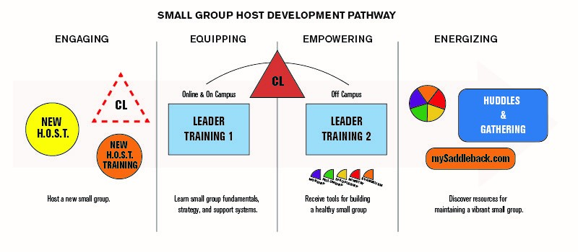

When you start groups, your leaders need to know what you want them to do. Not only do you need to know your “end in mind”; you need the same for your small group leaders. Just like Jesus took His disciples from “come and see” through a three year relational process to “come and die”; we too have a relational process for our “hosts” to become “leaders”. Now we pray none of them need to die, but we do want to take them from where they are to a deeper commitment in Christ. Whatever you design, know where you want to take your leaders.

Matthew 4:19 NLT
“Jesus called out to them, ‘Come, follow me, and I will show you how to fish for people!’”

Psalms 17:5 NLT
“My steps have stayed on your path; I have not wavered from following you.”

- Leader Training
- Tools. Our 2 measurables Individual health and group health
- Video Curriculum

- What’s your _______HEART GUARDRAIL ___________?

- Relational
- Data
- Gatherings

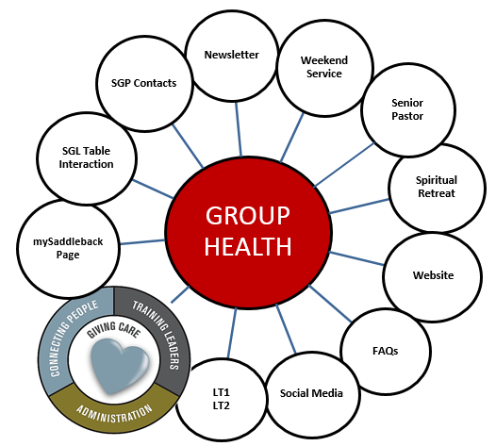

It’s easy to start groups; it’s hard to sustain them. Since 1998, our small group team has seen our small groups grow from 250 groups to over 7,000 groups. That doesn’t happen without infrastructure. Just like a city needs roadways to develop as a town turns into a city, your small group ministry needs its roadways. Two critical parts of your infrastructure are Community Leaders (CL’s) who are the leaders of leaders. They are the relational arm of your ministry. They provide the care and direction to your small groups. They help with focus so groups don’t drift. At Saddleback we have over 500 volunteer CL’s who give their time for the betterment of our small group community. Another part is “Gatherings”. Gatherings are the vision arm of your ministry. A gathering is bringing your leaders together periodically for appreciation, vision and recruitment. It can be done over dinner or coffee. At Saddleback we do two Gatherings a year, one in the beginning of the year (to get us out of the holiday funk) and in August (to gear us up for the fall).

- SGWP, chapter 14
- 1:25 verse 1:5
- 4 P’s Can’t manage what you don’t measure
- Takes a village to raise a healthy group

Proverbs 27:23 NLT
“Know the state of your flocks, and put your heart into caring for your herds”

1 Peter 5:2-3 NLT
“Care for the flock that God has entrusted to you. Watch over it willingly, not grudgingly—not for what you will get out of it, but because you are eager to serve God. Don’t lord it over the people assigned to your care, but lead them by your own good example.”

- Don’t _________ STAND _________ alone!

The enemy loves to lead in isolation and fear. Fear stops us from taking risks for the Kingdom. Isolation cuts off our supply lines so we can’t fight the good fight! In 2006 God inspired me to start the Small Group Network so that no one would stand alone. Because we realize we are better together!

I know what it’s like to do the day in and day out ministry of running a small group ministry. I don’t sit in an ivory tower writing things I think might be true, but write out of the 30 years of doing small group ministry in churches of all sizes. I know what it’s like to be the only one in your church thinking community. I am blessed with an incredible staff. My prayer is this Network will be your staff, standing with you to help you fight the good fight. Don’t think you need others around you—think again! To learn more about this free Network, see http://www.smallgroupnetwork.com.

- Story of two guys in Nashville area
- Global network

1 Corinthians 3:8 NLT
“The one who plants and the one who waters work together with the same purpose. And both will be rewarded for their own hard work.”

1 Corinthians 12:27 NLT
“All of you together are Christ’s body, and each of you is a part of it.”

Ephesians 2:20-21 NLT
“Together, we are his house, built on the foundation of the apostles and the prophets. And the cornerstone is Christ Jesus himself. We are carefully joined together in him, becoming a holy temple for the Lord. Through him you Gentiles are also being made part of this dwelling where God lives by his Spirit.”

- Prepare your ________ HEART __________.

Probably the greatest thing I’ve learned along the way I learned in Seminary. It’s called the Messiah complex. It’s where you take on the role of the Messiah and bear everyone’s burdens on your cross. The problem is, you can’t do it. You will burn out. Symptoms are a lack of quiet time and/or Sabbath forgetfulness. Just as God can take your financial tithe and make 90% go farther than your best 100%; He can do the same with a Sabbath. He can make 6 days go farther than your best 7 days. The principle God is working on has nothing to do with finances or time, it’s all about obedience. If you don’t prepare your heart now, the work FOR God will destroy the work OF God in your life.

Galatians 6:4-5 NLT
“Pay careful attention to your own work, for then you will get the satisfaction of a job well done, and you won’t need to compare yourself to anyone else. For we are each responsible for our own conduct.”

- No one gets into a spiritual hole with a back-hoe, but with a spoon…no one wakes up…
- Could I encourage you to do a leadership check up? Time, Tithe and Team
- What’s your Spiritual Health look like?

John 10:10 NLT
“The thief’s purpose is to steal and kill and destroy. My purpose is to give them a rich and satisfying life.”

Fill-in answers:
1. HEADED
2. LAY OF THE LAND
3. RUN POINT
4. TEAM
5. STRATEGY
6. START
7. HEAD GUARDRAIL
8. HEART GUARDRAIL
9. STAND
10. HEART

